Patient Number Estimation
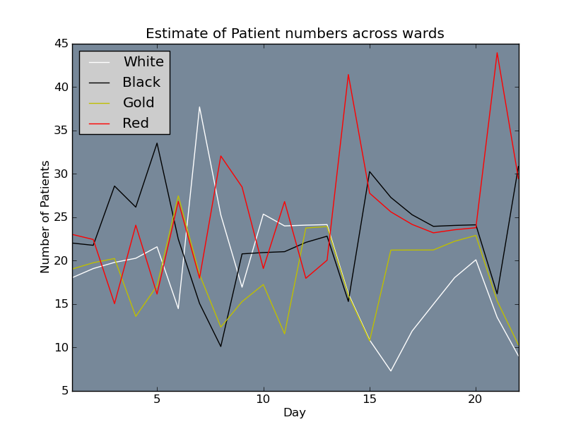
Figure 1: Estimate of number of patients in each ward based on the first three weeks of the current schedule.
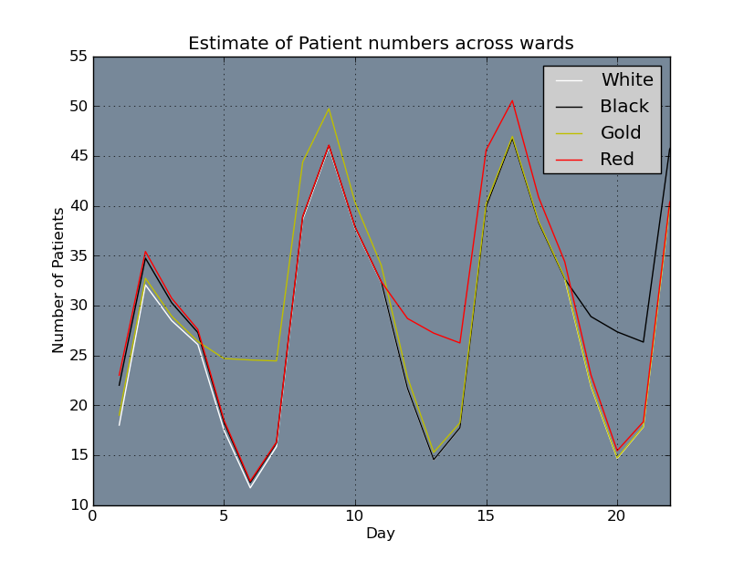
Figure 2: Estimate of number of patients per ward based on initial generation of rotating roster
Assumptions:
- 28 patients admitted Monday to Wednesday
- 32 patients on Friday
- Even split of patients across on-call wards
- 28 patients on Saturday and 20 on Sunday with ‘A’ call taking all the patients
- 1/3 of patients are discharged each day

